Teams are seated in Sections are the very back of the arena. They are shaded here.

Side One:

Side Two: 103, 104, 105, 106 plus 204, 205, 206

Side Two: 125, 126, 126, 127, 25, 24, 226, 225, 224

Draped curtain will be at about the 108 and 122 areas I believe. Could be one before but it is hard to tell on this map.

Mats are in this back area and go all the way up to the curtain. We are trying to prevent teams from a cross over on the mats.

Side One will come to floor at their side entrance. We will then move them around the back mat, down the hall way to MAT ONE/SIDE ONE. Side Two will do the same and as they rotate through teams will remain on the side they entered on

Exits when they have completed their performance will be located directly under Section 11 and 19.

I have requested maps showing the lower concourse level so you can see it better. This is about as close as the computer artist that I am not can get this thing.

Side ONE

Side TWO

Teams will walk directly into the arena and enter at floor level and be seated

Teams registering in Tunnel One will continue across the back hall and move down the hall under the seating

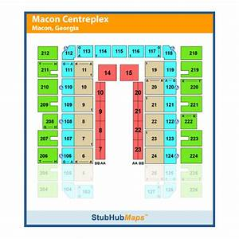

Tunnel One – Odd Teams, Registration

Registration

Tunnel Two – Even numbers